Overdose Washroom Safety Assessment Tool

SECTION 2 – WASHROOM ASSESSMENT – COMPLETE FOR EACH WASHROOM
- WASHROOM ASSESSMENT
TO BE COMPLETED BY OPERATIONS
QUESTION |  | YES | NO
WASHROOM DESCRIPTION
- Brief description of washroom (e.g. 2nd floor wheelchair access)
- Where is the washroom? ☐Main floor ☐Basement ☐2nd floor or higher; floor #:________ ☐Outdoors
- What is the washroom type? ☐Women ☐Men ☐Universal
VISIBILITY/MONITORING
- Does the front desk have line of sight to this washroom? |  | ☐ | ☐
- Does the washroom experience a lot of foot traffic? |  | ☐ | ☐
- Is the washroom monitored for safety? |  | ☐ | ☐
If yes:
  - How often is it monitored? __________________
  - Who monitors the washroom? ☐Peers ☐Security ☐Custodial staff ☐Program staff ☐Other: __________________
  - What is the documentation method? ☐Washroom log on wall ☐Log book ☐Other: __________________
OUTER DOOR (IF APPLICABLE)
- Is there an outer door? |  | ☐ | ☐
- Does the washroom have trans/gender inclusive signage? |  | ☐ | ☐
- Does the door swing out? |  | ☐ | ☐
- What is the lock type? ☐Dead bolt 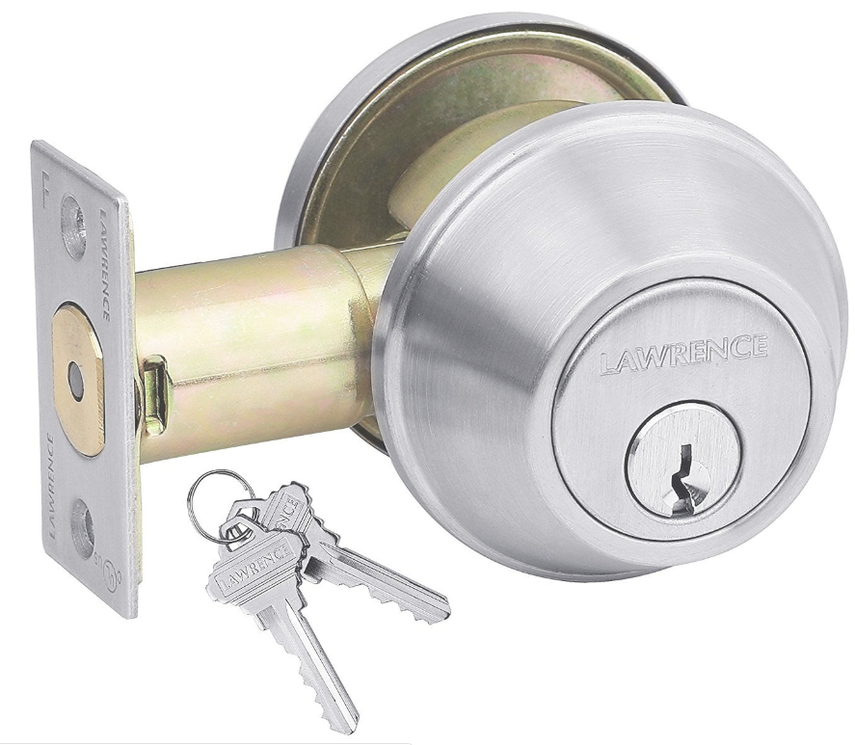☐Doorknob lock 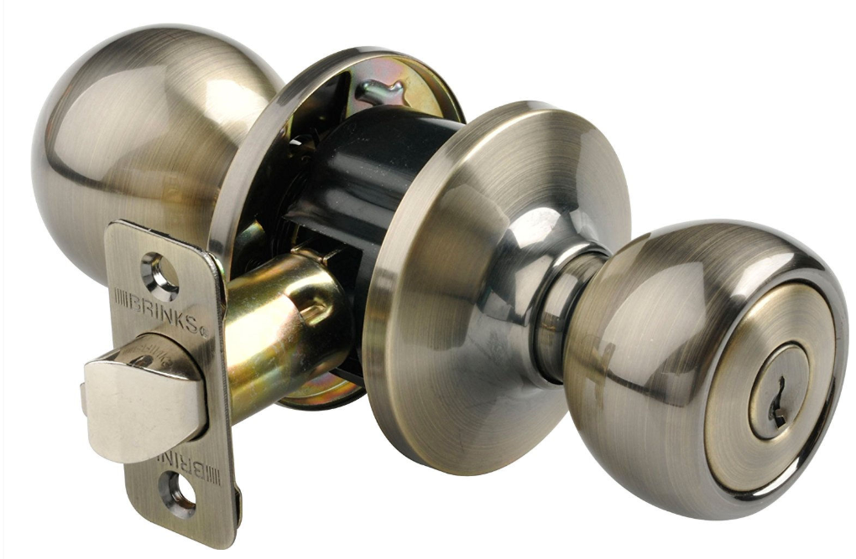 ☐Lob door handle 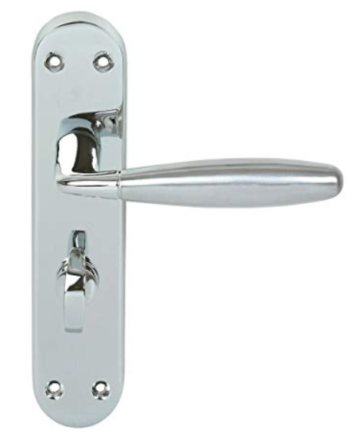 ☐Slotted lock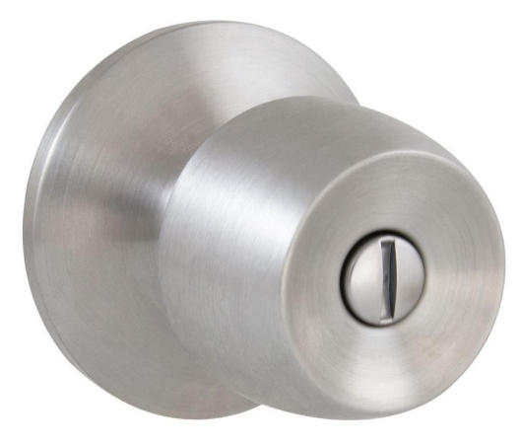
☐Sliding door lock 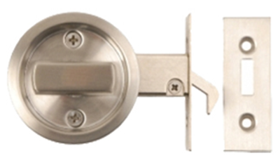 ☐Door hook latch 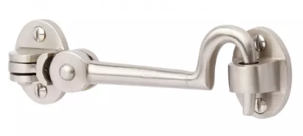 ☐Barrel Bolt 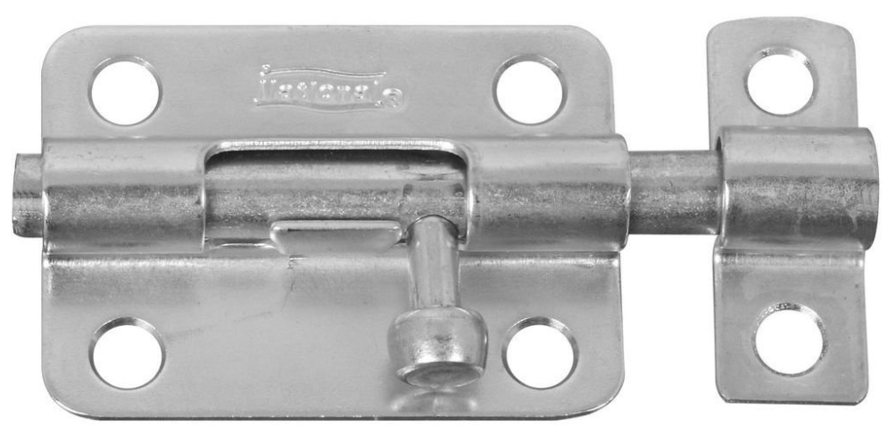 ☐Chain lock 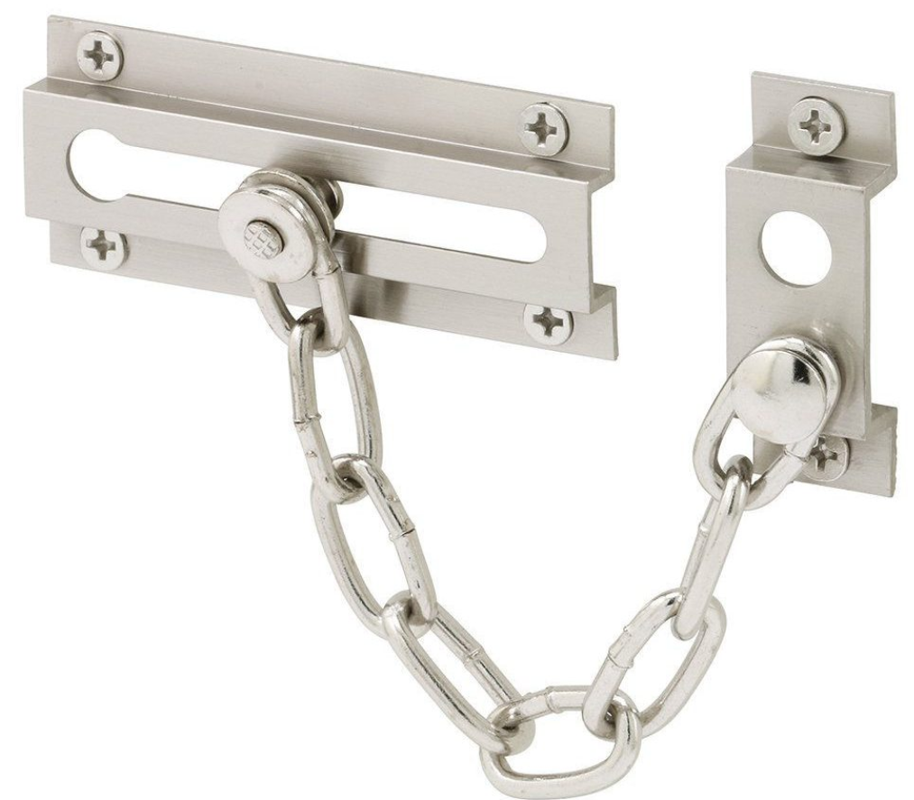
☐Other: __________________
- For slotted locks, do staff have access to a tool to open the lock (e.g. a coin or screwdriver)? |  | ☐ | ☐
- Does the door lock from the inside? |  | ☐ | ☐
- Is there a master key? |  | ☐ | ☐
- If yes: do all staff have a master washroom key and/or know where the master key is kept? |  | ☐ | ☐
- Is the door usually left open? |  | ☐ | ☐
- Is the door usually left unlocked? |  | ☐ | ☐
- What type of timer system is used? ☐N/A ☐Automatic ☐Manual (e.g. egg timer)
ACCESSIBILITY AND SAFETY
- Is the washroom wheelchair accessible? |  | ☐ | ☐
- Is there a naloxone kit in the washroom? |  | ☐ | ☐
- Is there a needle box in the washroom? |  | ☐ | ☐
If yes:  - If yes, is it tamperproof?  - Is it fixed to the wall?  - Is it in stalls? |  | ☐  ☐  ☐ | ☐  ☐  ☐
SIGNAGE AND INFORMATION
- Is there signage indicating the destigmatization of drug use? |  | ☐ | ☐
- Is information on overdose prevention site / harm reduction posted? |  | ☐ | ☐
- Is information on overdose/ emergency response posted? |  | ☐ | ☐
- Is signage for treatment services / detox posted? |  | ☐ | ☐
- Is information on mental and physical health care posted? |  | ☐ | ☐
STALL DOOR (IF APPLICABLE)
- Does the door swing out? |  | ☐ | ☐
- What is the lock type? |  | ☐ | ☐
- Does the door lock from the inside? |  | ☐ | ☐
- Is there a master key? |  | ☐ | ☐
- Is the door usually left open? |  | ☐ | ☐
- Is the door usually left unlocked? |  | ☐ | ☐
- Is there a space of at least 8” between the floor and door to see if someone is in distress? |  | ☐ | ☐
- Are tools required to remove the door? |  | ☐ | ☐
- Can the door be lifted off the hinges? |  | ☐ | ☐
STALL FEATURES
- Is the stall large enough for emergency responders? |  | ☐ | ☐
- Can more than one person fit in the stall? |  | ☐ | ☐
- Could a person get lodged between the toilet and wall? |  | ☐ | ☐
- Is the stall well lit? |  | ☐ | ☐
- Is there a shelf or table in the stall? |  | ☐ | ☐
- Is there a call button in the stall? |  | ☐ | ☐
- Are there places to hide/retrieve used needles? ☐Cisterns ☐Ceiling ☐Ventilation covers ☐Garbage bin ☐None

COMMENTS

Include measurements from stall door to floor – must be at least 8”.

TO BE COMPLETED BY WASHROOM ASSESSMENT TEAM
RECOMMENDATIONS | COSTS
CAPITAL

OPERATING

