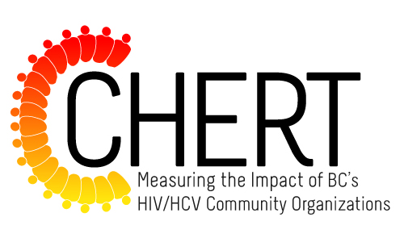

Call for Peer Involvement: The CHERT Outcomes Working Group
Applications Due: 4:00pm on Friday, November 21, 2014

The BC HIV/HCV Evaluation Advisory Group is looking for people living with HIV or who have lived experience with HCV to assist them in developing outcomes indicators for the Community HIV/HCV Evaluation and Reporting Tool (CHERT). Candidates should have some past experience participating, supporting and/or conducting community-based research and/or evaluation projects. Successful candidates will become integral members of the CHERT Outcomes Working Group.

Led by the Pacific AIDS Network (PAN), the CHERT is an online survey tool for community-based HIV/HCV organizations in BC. It collects process data about a range of programs and services organizations provide. Currently, the CHERT collects only process-level indicators from responding organizations, rather than outcome-level data. Information on outcomes indicators would allow for the community-based HIV/HCV sector to demonstrate the value and impact of their work across the HIV/HCV Prevention and Care Cascade, including STOP HIV/AIDS. For more information about the CHERT, visit this link: http://pacificaidsnetwork.org/the-community-hivhcv-evaluation-and-reporting-tool-chert-2/

What will you be asked to do as a member of The CHERT Outcomes Working Group?
Team members will be asked to draw upon their past and continued involvement in community-based health evaluation and research to collaboratively guide the development of outcomes indicators for the CHERT.

What are the timelines and time commitments?
Between November 2014 to March 2015, you will be asked to attend two face-to-face meetings and up to two teleconferences.

Will I be compensated for my time and effort?
Peer Working Group members will receive an honorarium for their work and commitment to the project.

For more information, please contact: Elayne Vlahaki at Elayne@catalyst-consulting.ca

If you are interested in this opportunity, please complete the Application Form to the best of your ability (see the following page).

Application Form
Deadline: 4:00pm on Friday, November 21, 2014

Name: ________________________________________________________________________

Phone # and/or email: ___________________________________________________________

Please answer the following questions.

- Why would you like to become a member of the CHERT Outcomes Working Group?

- How would you describe your previous experience (if any) with evaluation and/or research (e.g. peer research associate, advisory group member, research participant, researcher/evaluator)?

Please submit your application to: elayne@catalyst-consulting.ca by Friday, November 21, 2014

